**AIM: Introduction to VI editor and procedure to execute lex program.**

1. **Introduction of “VI” Editor with Commands.**

* The vi editor tool is an interactive tool as it displays changes made in the file on the screen while you edit the file. In vi editor you can insert, edit or remove a word as cursor moves throughout the file.
* Basic Commands:

|  |  |
| --- | --- |
| **Command** | **Description** |
| i | Insert at cursor (goes into insert mode) |
| ESC | Terminate insert mode |
| u | Undo last change |
| U | Undo all changes to the entire line |
| o | Open a new line (goes into insert mode) |
| dd | Delete line |
| 3dd | Delete 3 lines. |
| D | Delete contents of line after the cursor |
| C | Delete contents of a line after the cursor and insert new text. Press ESC key to end insertion. |
| dw | Delete word |
| :w | Save the file but keep it open |
| :q! | Quit vi and do not save changes |
| :wq | Save the file and quit |
| vi | If file no exist then create and open it. If file exist simply open it. |
| touch | The touch command is a standard program for Unix/Linux operating system that is used to create changes and modify timestamps of a file. |
| cat | cat command allows us to create single or multiple files, view contain of t=file and redirect output in terminal of files. |
| ls | ls command is one of the most frequently used command in linux. by using ls command you list out files and directory. |
| ls –l | ls –l shows file or directory, size, modified sate and time, file or folder name and owner of the file and its permission. |
| mkdir | use to create empty directory |
| who | The who command print information about all users who are currently logged in. |
| clear | Cleare all text on the screen and display a new prompt. |
| rmdir | rmdir command removes each directory specified on the command line, if the are empty. |
| chmod | chmod command use to change the permission of file or directory. |
| cd | cd command use to change the directory |

1. **Introduction of Lex.**

* Introduction of Lex.
* Lex is a program that generates lexical analyzer. It is used with YACC parser generator. The lexical analyzer is a program that transforms an input stream into a sequence of tokens. It reads the input stream and produces the source code as output through implementing the lexical analyzer in the C program.

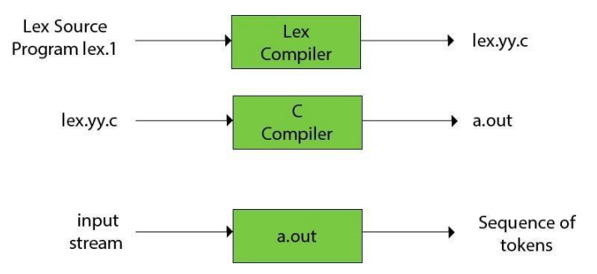

**Lex File Formate:**

%{

/* Declaration section */

%}

%%{

/* Rule and Action section */

%%}

/* Main or C program section */

1. **Explain How to Compile Lex program with sample program.**

**Code:**

%{

int upper=0,lower=0,digit=0,symbol=0;

%}

%%{

[a-z] {lower++;}

[A-Z] {upper++;}

[0-9] {digit++;}

. {symbol++;}

"\n" {return 0;}

%%}

int yywrap() {}

int main()

{

printf("Enter String: ");

yylex();

printf("Uppercase count: %d\n",upper);

printf("Lowercase count: %d\n",lower);

printf("Digit count: %d\n",digit);

printf("Special Symbol count: %d\n",symbol);

return 0;

}

**Output:**

